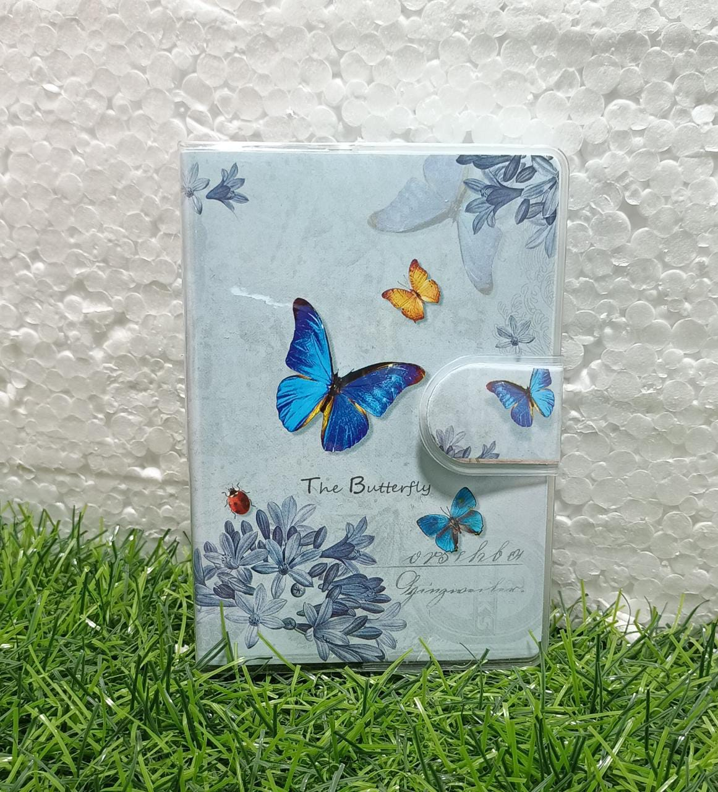

**3D BUTTERFLY JOURNAL**

RYANA CALENDARS is selling wonderful 3D BUTTERFLY journals! at reasonable prices. It contains beautiful and designable covers!

**RS 880**